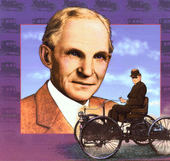 Henry Ford
- What is an inventor?
________________________________________________
- What did Henry Ford invent?
________________________________________________
- What did the first car cost?
________________________________________________
- What color was the Model T?
_________________________________________________
- How fast could it go?
_______________________________________________-
- What was the name of the company Henry Ford founded?
________________________________________________
- In what year was the Model T invented? www.askjeeves.com

