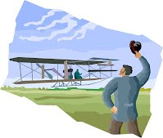The Wright Brothers
- What is an inventor?
________________________________________________
- What did the Wright Brothers invent?
________________________________________________
- What was the first airplane made of?
________________________________________________
- How far did it fly?
_________________________________________________
- What are planes made of today?
_______________________________________________-
- What are planes powered by?
________________________________________________
- In what year was the airplane invented? www.askjeeves.com

