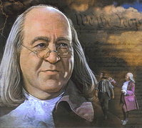 Benjamin Franklin
- What is an inventor?
________________________________________________
- What did Benjamin Franklin invent?
________________________________________________
- How did he prove that lightning was electricity?
________________________________________________
- What other two occupations did he have?
_________________________________________________
- What two important documents did Franklin help write?
_______________________________________________-
- Why are lightning rods on building today?
________________________________________________
- In what year did Ben Franklin fly his kite into lightning? www.askjeeves.com

