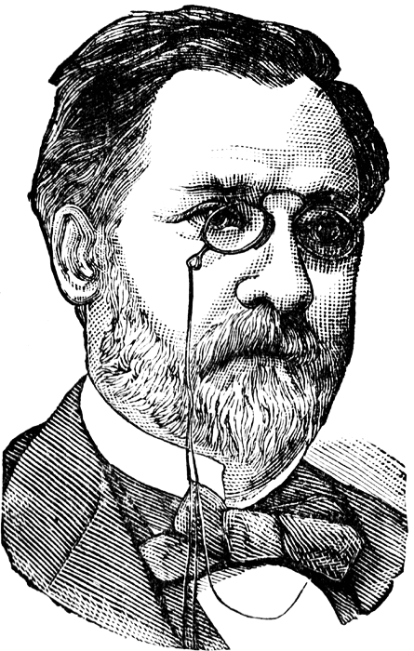Louis Pasteur
- What is an inventor?
________________________________________________
- What did Louis Pasteur invent?
________________________________________________
- Why is pasteurization important?
________________________________________________
- What are microbes?
_________________________________________________
- What are vaccines?
_______________________________________________-
- Why are vaccines important today?
________________________________________________
- In what year did Louis Pasteur invent pasteurization? www.askjeeves.com

