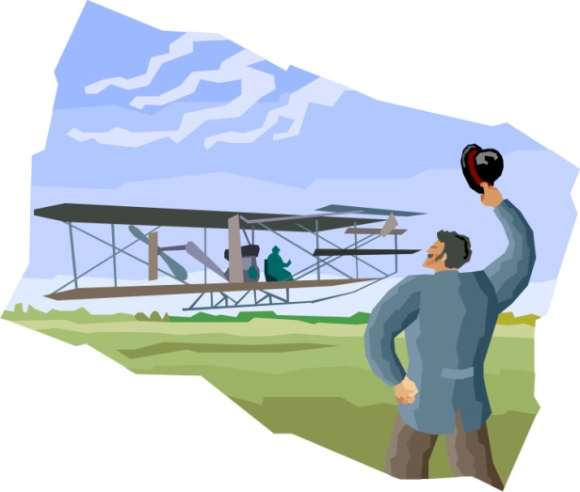Orville and Wilbur Wright

1. An inventor is _______________________________
2. Orville and Wilbur Wright were _________________

and _________________________.

1. They invented the first ________________________.
2. Their longest flight was _________________________

_________________________________________________.

1. They later opened _____________________________

_________________________________________________.

1. The first plane was made of _____________________.
2. The first plane was powered by _____________________.