[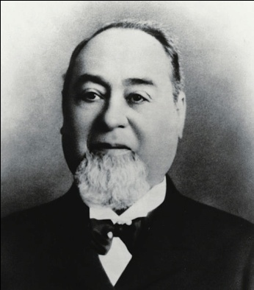](http://upload.wikimedia.org/wikipedia/commons/d/d5/Levi_Strauss_1.jpg)[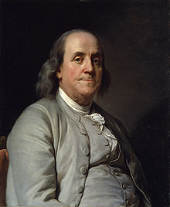](http://en.wikipedia.org/wiki/File:BenFranklinDuplessis.jpg)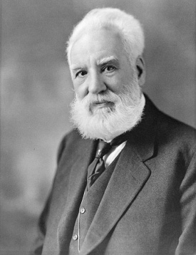

Alexander Graham Benjamin Franklin Levi Strauss invented

Bell invented the invented the lightning blue jeans in 1853.

telephone in 1876. Rod in 1752.

[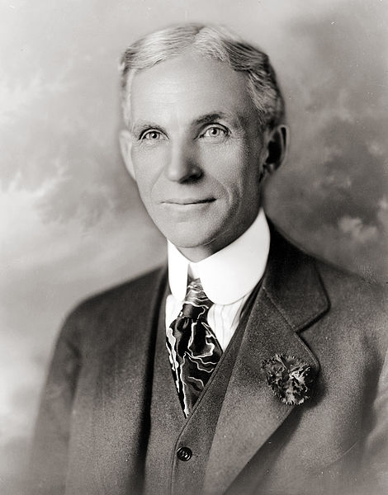](http://upload.wikimedia.org/wikipedia/commons/1/18/Henry_ford_1919.jpg)[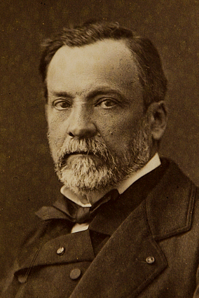](http://upload.wikimedia.org/wikipedia/commons/3/31/Louis_Pasteur_by_Pierre_Lamy_Petit.jpg)[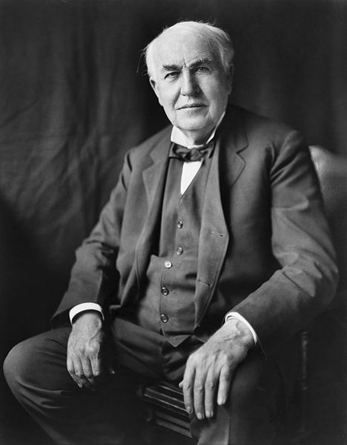](http://upload.wikimedia.org/wikipedia/commons/9/9d/Thomas_Edison2.jpg)

Thomas Edison invented Louis Pasteur invented Henry Ford invented a

the light bulb in 1879. pasteurization in 1862. car in 1908.

[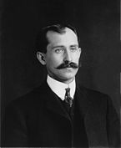](http://en.wikipedia.org/wiki/File:Orville_Wright.jpg)[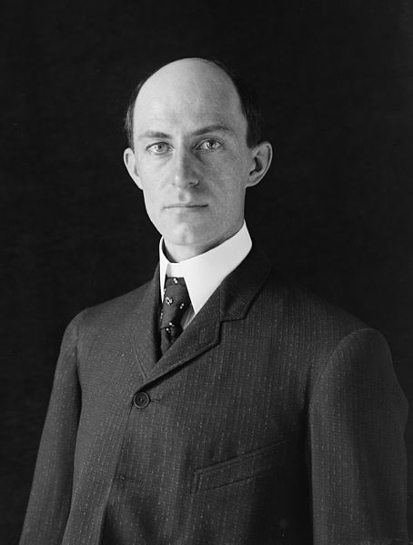](http://upload.wikimedia.org/wikipedia/commons/7/77/Wilbur_Wright.jpg)[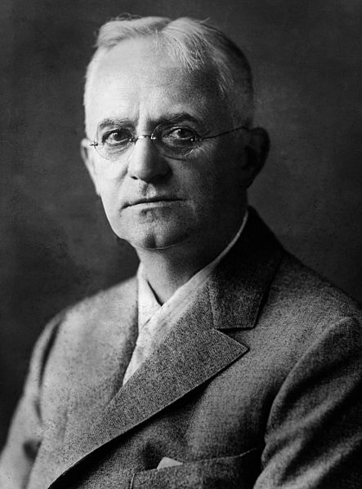](http://upload.wikimedia.org/wikipedia/commons/e/ec/GeorgeEastman2.jpg)[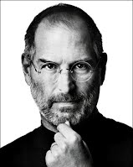](https://sites.google.com/a/maquoketa-v.k12.ia.us/inventors-webquest-2nd-grade/home/steve-jobs1.jpg?attredirects=0)

Steve Jobs invented George Eastman Orville and Wilbur Wright invented

the Iphone in 2007. Invented the Kodak the airplane in 1903.

camera in 1888.